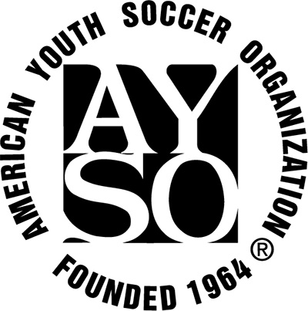

2017 GAME SCHEDULE SLOTS

September 9th-October 28th
Rainy Day Make Up Option: November 4th
(no games currently scheduled for Nov 4th)

Season Closer Soccerfest Nov 11-12
(specific schedule to post mid-season)

4U / 5U: Saturdays: 8:00am-8:45am

6U: Saturdays: 9:00am-10:00am

8U: Saturdays: 10:00am-12:00pm

10U: Saturdays: 11:00am-1:00pm

12U: Saturdays: 11:00am-1:00pm

14U: Subject to Interplay

